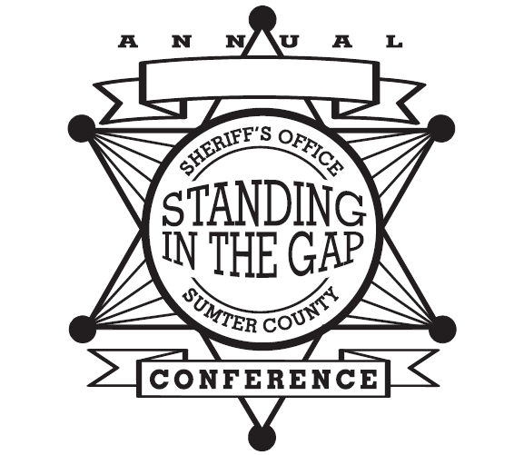
Sumter County Sheriff’s Office
10th ANNUAL BOYS TO MEN CONFERENCE
8th ANNUAL GIRLS TO WOMEN CONFERENCE
June 17-18, 2016 (Boys)& (Girls)

Application/Permission and Release of Liability Form

Name of Participant: _____________________________ Age: ____ Grade: ____ Sex: _____
Address: ___________________________________________________________________
Special Talent: __________________________________________ T-shirt size__________
Parent/Guardian Name: __________________________ Contact No.___________________
(Please respond to the following by putting your initials by the yes or no)
- Does your child have any allergies or medical conditions that will prevent or limit his participation in this program that we should know of in case of a medical emergency? Yes____ or No____
- Is there any reason why your child should not participate in sporting activities? Yes____ or No _____
- Is there any reason why your child cannot participate in swimming activities? Yes_____ or No _____
- If your child is 12 yrs or older, is there any reason why your child cannot participate in the jail tour? Yes_____ or No______
- Does your child take medication that will need to be administered during the conference? Yes______ or No______ (If yes please provide medication name and administering specifications)
______________________________________________________________
Permission to video/photograph/attend session on Abstinence and Sexually Transmitted Diseases
As the parent/guardian of ____________________________, I hereby give permission for my child to be videoed/photographed and later used for training/public relations purposes and to participate in the discussion on abstinence. I also give my permission for my child to participate in the Medieval Times and Myrtle Waves Water Park Field Trip in Myrtle Beach, SC on June 17, 2016.
(Please respond by providing your initials by Yes or No) ______Yes or No _______
I hereby release The Sumter County Sheriff’s Office and all sponsors/participants
and their agents from any liability or any consequences of my request
for my child to participate in the aforementioned activity.

Date: _____________ Signature of Parent/Guardian: _____________________________
Date: ______________ Signature of Witness: ________________________________________

Deadline for application to be submitted to the Sumter County Sheriff’s Office: Friday, June 03, 2016

Fee: $35.00 (Non-Refundable)
Please make checks or money orders payable to:
Boys & Girls Youth Incorporated
P. O. Box 430
Sumter, S. C. 29151-0430

The Sumter County Sheriff’s Office will be hosting its Annual Boys & Girls Youth Conferences. This year both conferences will be held on June 17th and 18th 2016. The Boys will be housed at Chestnut Oaks Middle School located at 1200 Oswego Hwy., Sumter, SC; and The Girls will be housed at Crestwood High School located at 2000 Oswego Rd., Sumter, SC.

The conferences are aimed at building character and leadership skills among boys and girls ages 10 to 18 if still in high school. Topics of discussion include; positive and negative effects of social media, drug prevention, healthy relationships, information technology and so much more. We promote education and a deep desire to attend institutions of higher learning. Registration fee is $35 per camper. Registration will be 6:30am-8:00am Friday morning at Crestwood High School with various other activities scheduled throughout the day and evening. The campers will stay overnight and the conferences resume early Saturday morning. Graduation ceremonies are scheduled to begin at 12:30pm at Crestwood High School in the Auditorium, and the conferences will end at approximately 1:30pm Saturday. Parents are encouraged to attend graduation.

Each camper is to bring any medications needed; female personal items, and personal hygiene items to include soap, toothbrush, toothpaste, and deodorant; wash towels, and bed covers. We will not be responsible for any lost electronics. Campers (boys & girls) may wear shorts, but the length should extend to the knees. Otherwise, shorts are prohibited. Females may wear skirts provided they are knee length or below. Cots will be provided, therefore sleeping bags are optional. Meals & snacks will be provided throughout the conferences as well, to include breakfast on Friday morning. In addition to items needed the campers will also need to bring a swimsuit and beach towel. This year we will be traveling to Myrtle Beach, SC to Medieval Times and Myrtle Waves Water Park on Friday. The bus will depart from Crestwood High at approximately 830am and will return later that evening.

It is our mission to make our youth prosperous and productive citizens of the future. Applications may be picked up at the Sheriff’s Office, and for more information, contact: Major Terrance Colclough at (803) 436-2032, Lt. Petrina Wiley at (803) 436-2026 or Cpl. Fred Brantley 495-8069 ext. 419. Annual Youth Conference applications may also be retrieved from our website at www.sumtersheriff.org. Deadline for applications will Friday June 03, 2016 at 5:00pm.

Anthony Dennis
Anthony Dennis, Sheriff

S H E R I F F A N T H O N Y D E N N I S

Sumter County
Sheriff’s Office

OFFICE
1281 North Main St
Sumter, SC 29153

PHONE
(803) 436-2051

FAX
(803) 436-2054

EMAIL
adennis@sumtercountysc.org

WEB
www.sumtersheriff.org

